МИНИСТЕРСТВО НАУКИ И ВЫСШЕГО ОБРАЗОВАНИЯ
РОССИЙСКОЙ ФЕДЕРАЦИИ
ФЕДЕРАЛЬНОЕ ГОСУДАРСТВЕННОЕ БЮДЖЕТНОЕ ОБРАЗОВАТЕЛЬНОЕ УЧРЕЖДЕНИЕ ВЫСШЕГО ОБРАЗОВАНИЯ «АСТРАХАНСКИЙ ГОСУДАРСТВЕННЫЙ УНИВЕРСИТЕТ
ИМЕНИ В.Н. ТАТИЩЕВА»

Факультет цифровых технологий и кибербезопасности
Кафедра цифровых технологий

Лабораторная работа №6
«Проектирование базы данных и пользовательского интерфейса информационной системы»
выполнена в рамках изучения дисциплины
«Архитектура информационных систем»

Направление подготовки: 09.03.02 Информационные системы и технологии
Направленность (профиль): Прикладные информационные системы

Исполнитель: студент группы ДИФ-15
Кузургалиев Р.А. ___________
Преподаватель: доцент кафедры ИТ
Синельщиков А.В. ___________

Оценка «______________________»

Астрахань – 2025

СОДЕРЖАНИЕ РАБОТЫ
ВВЕДЕНИЕ
Цель: Целью данной лабораторной работы является:
- Получить практические навыки проектирования физической структуры базы данных на основе концептуальной модели данных (диаграммы классов).
- Научиться создавать SQLскрипты для определения структуры базы данных (DDL) и манипулирования данными (DML), соответствующие основным операциям системы.
- Освоить инструменты для визуального проектирования баз данных и пользовательских интерфейсов.
- Разработать макеты пользовательского интерфейса (UI) для ключевых сценариев использования информационной системы, связывая их с потоками данных и взаимодействиями, смоделированными ранее.
- Закрепить понимание взаимосвязи между бизнес-требованиями, моделями системы (UML, DFD) и конкретными артефактами проектирования (ERD, SQL).
Лабораторная работа №6. «Проектирование базы данных и пользовательского интерфейса информационной системы»
Вариант задания: Система бронирования авиабилетов, предназначенная для удобного поиска, бронирования, покупки авиабилетов.
ХОД РАБОТЫ

ER-ДИАГРАММА
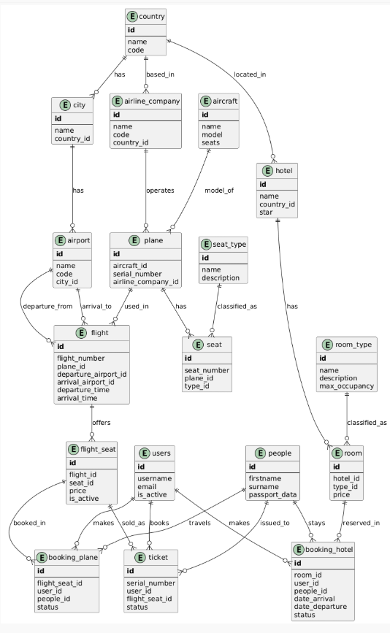

ЛОГ ИСПОЛНЕНИЯ ЗАПРОСА
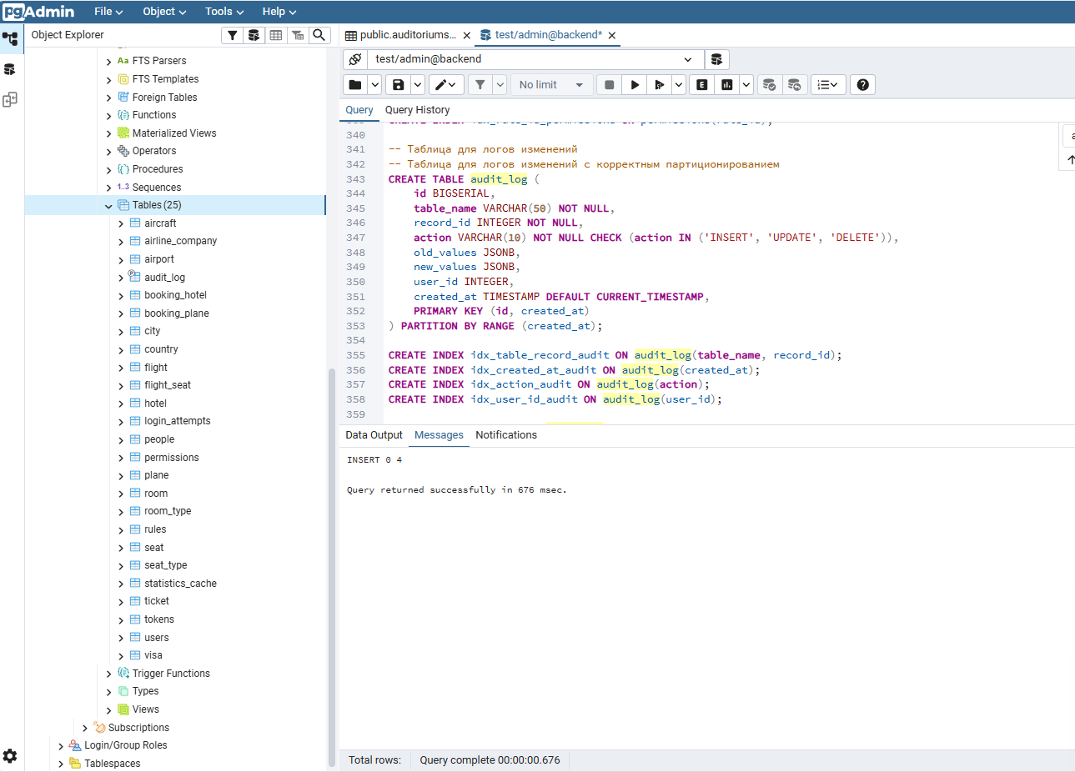

СХЕМА БД ОТ PGADMIN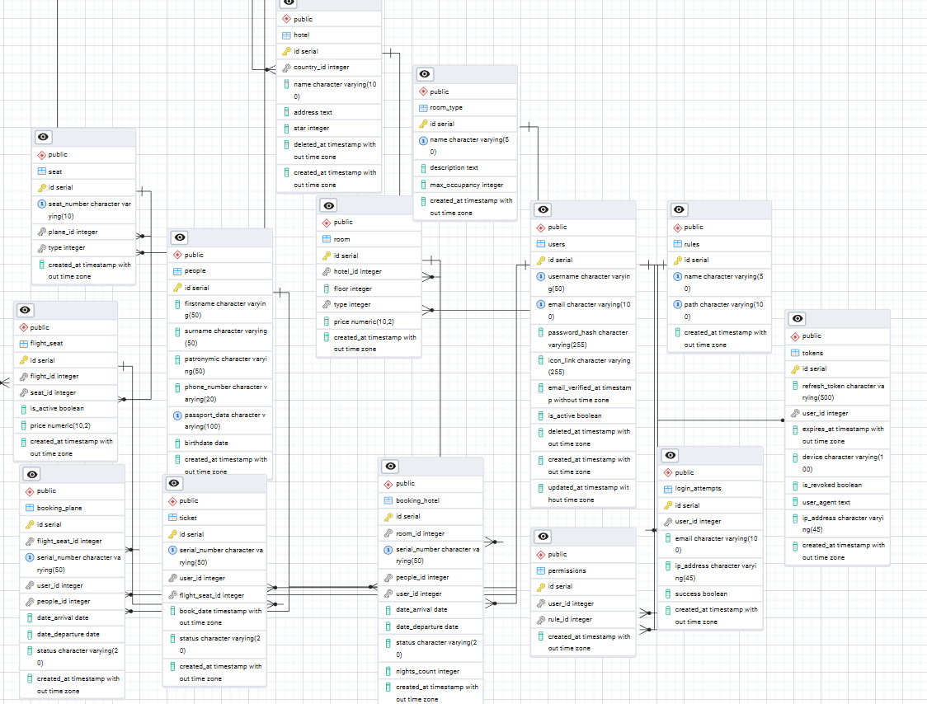
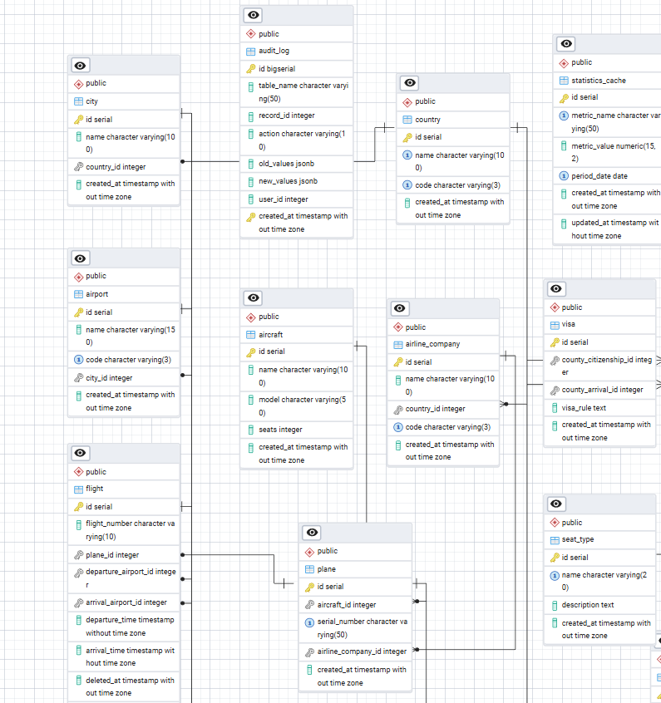
ТЕКСТ СКРИПТА
-- Таблица типов мест
CREATE TABLE seat_type (
id SERIAL PRIMARY KEY,
name VARCHAR(20) NOT NULL UNIQUE,
description TEXT,
created_at TIMESTAMP DEFAULT CURRENT_TIMESTAMP
);

-- Таблица типов комнат
CREATE TABLE room_type (
id SERIAL PRIMARY KEY,
name VARCHAR(50) NOT NULL UNIQUE,
description TEXT,
max_occupancy INTEGER DEFAULT 1 CHECK (max_occupancy > 0),
created_at TIMESTAMP DEFAULT CURRENT_TIMESTAMP
);

-- Таблица пользователей
CREATE TABLE users (
id SERIAL PRIMARY KEY,
username VARCHAR(50) NOT NULL UNIQUE,
email VARCHAR(100) NOT NULL UNIQUE,
password_hash VARCHAR(255) NOT NULL,
icon_link VARCHAR(255),
email_verified_at TIMESTAMP NULL,
is_active BOOLEAN DEFAULT TRUE,
deleted_at TIMESTAMP NULL,
created_at TIMESTAMP DEFAULT CURRENT_TIMESTAMP,
updated_at TIMESTAMP DEFAULT CURRENT_TIMESTAMP,
CONSTRAINT chk_email_format CHECK (email ~ '^[A-Za-z0-9._%-]+@[A-Za-z0-9.-]+\.[A-Za-z]{2,4}$'),
CONSTRAINT chk_password_length CHECK (CHAR_LENGTH(password_hash) >= 60)
);

CREATE INDEX idx_user_activity ON users(is_active, email_verified_at);
CREATE INDEX idx_user_deleted ON users(deleted_at);

-- Функция для автоматического обновления updated_at
CREATE OR REPLACE FUNCTION update_updated_at_column()
RETURNS TRIGGER AS $$
BEGIN
NEW.updated_at = CURRENT_TIMESTAMP;
RETURN NEW;
END;
$$ language 'plpgsql';

-- Таблица попыток входа
CREATE TABLE login_attempts (
id SERIAL PRIMARY KEY,
user_id INTEGER NULL,
email VARCHAR(100) NOT NULL,
ip_address VARCHAR(45) NOT NULL,
success BOOLEAN DEFAULT FALSE,
created_at TIMESTAMP DEFAULT CURRENT_TIMESTAMP,
FOREIGN KEY (user_id) REFERENCES users(id) ON DELETE SET NULL
);

CREATE INDEX idx_email_ip ON login_attempts(email, ip_address);
CREATE INDEX idx_created_at ON login_attempts(created_at);

-- Таблица стран
CREATE TABLE country (
id SERIAL PRIMARY KEY,
name VARCHAR(100) NOT NULL UNIQUE,
code VARCHAR(3) NOT NULL UNIQUE,
created_at TIMESTAMP DEFAULT CURRENT_TIMESTAMP
);

-- Таблица городов
CREATE TABLE city (
id SERIAL PRIMARY KEY,
name VARCHAR(100) NOT NULL,
country_id INTEGER NOT NULL,
created_at TIMESTAMP DEFAULT CURRENT_TIMESTAMP,
FOREIGN KEY (country_id) REFERENCES country(id) ON DELETE CASCADE
);

CREATE INDEX idx_country_id ON city(country_id);
CREATE INDEX idx_city_name ON city(name);

-- Таблица аэропортов
CREATE TABLE airport (
id SERIAL PRIMARY KEY,
name VARCHAR(150) NOT NULL,
code VARCHAR(3) NOT NULL UNIQUE,
city_id INTEGER NOT NULL,
created_at TIMESTAMP DEFAULT CURRENT_TIMESTAMP,
FOREIGN KEY (city_id) REFERENCES city(id) ON DELETE CASCADE
);

CREATE INDEX idx_city_id_airport ON airport(city_id);

-- Таблица виз
CREATE TABLE visa (
id SERIAL PRIMARY KEY,
county_citizenship_id INTEGER NOT NULL,
county_arrival_id INTEGER NOT NULL,
visa_rule TEXT,
created_at TIMESTAMP DEFAULT CURRENT_TIMESTAMP,
FOREIGN KEY (county_citizenship_id) REFERENCES country(id) ON DELETE CASCADE,
FOREIGN KEY (county_arrival_id) REFERENCES country(id) ON DELETE CASCADE
);

CREATE INDEX idx_citizenship ON visa(county_citizenship_id);
CREATE INDEX idx_arrival ON visa(county_arrival_id);

-- Таблица авиакомпаний
CREATE TABLE airline_company (
id SERIAL PRIMARY KEY,
name VARCHAR(100) NOT NULL,
country_id INTEGER NOT NULL,
code VARCHAR(3) NOT NULL UNIQUE,
created_at TIMESTAMP DEFAULT CURRENT_TIMESTAMP,
FOREIGN KEY (country_id) REFERENCES country(id) ON DELETE CASCADE
);

CREATE INDEX idx_country_id_airline ON airline_company(country_id);
CREATE INDEX idx_airline_name ON airline_company USING gin (to_tsvector('english', name));

-- Таблица моделей самолетов
CREATE TABLE aircraft (
id SERIAL PRIMARY KEY,
name VARCHAR(100) NOT NULL,
model VARCHAR(50) NOT NULL,
seats INTEGER NOT NULL CHECK (seats > 0),
created_at TIMESTAMP DEFAULT CURRENT_TIMESTAMP
);

-- Таблица самолетов
CREATE TABLE plane (
id SERIAL PRIMARY KEY,
aircraft_id INTEGER NOT NULL,
serial_number VARCHAR(50) NOT NULL UNIQUE,
airline_company_id INTEGER NOT NULL,
created_at TIMESTAMP DEFAULT CURRENT_TIMESTAMP,
FOREIGN KEY (aircraft_id) REFERENCES aircraft(id) ON DELETE CASCADE,
FOREIGN KEY (airline_company_id) REFERENCES airline_company(id) ON DELETE CASCADE
);

CREATE INDEX idx_aircraft_id ON plane(aircraft_id);
CREATE INDEX idx_airline_company_id ON plane(airline_company_id);

-- Таблица рейсов
CREATE TABLE flight (
id SERIAL PRIMARY KEY,
flight_number VARCHAR(10) NOT NULL,
plane_id INTEGER NOT NULL,
departure_airport_id INTEGER NOT NULL,
arrival_airport_id INTEGER NOT NULL,
departure_time TIMESTAMP NOT NULL,
arrival_time TIMESTAMP NOT NULL,
deleted_at TIMESTAMP NULL,
duration_minutes INTEGER GENERATED ALWAYS AS (EXTRACT(EPOCH FROM (arrival_time - departure_time)) / 60) STORED,
created_at TIMESTAMP DEFAULT CURRENT_TIMESTAMP,
FOREIGN KEY (plane_id) REFERENCES plane(id) ON DELETE CASCADE,
FOREIGN KEY (departure_airport_id) REFERENCES airport(id) ON DELETE CASCADE,
FOREIGN KEY (arrival_airport_id) REFERENCES airport(id) ON DELETE CASCADE,
CONSTRAINT chk_arrival_after_departure CHECK (arrival_time > departure_time)
);

CREATE INDEX idx_plane_id_flight ON flight(plane_id);
CREATE INDEX idx_departure_airport ON flight(departure_airport_id);
CREATE INDEX idx_arrival_airport ON flight(arrival_airport_id);
CREATE INDEX idx_flight_dates ON flight(departure_time, arrival_time);
CREATE INDEX idx_flight_route ON flight(departure_airport_id, arrival_airport_id, departure_time);

-- Таблица мест в самолете
CREATE TABLE seat (
id SERIAL PRIMARY KEY,
seat_number VARCHAR(10) NOT NULL,
plane_id INTEGER NOT NULL,
type INTEGER NOT NULL,
created_at TIMESTAMP DEFAULT CURRENT_TIMESTAMP,
FOREIGN KEY (plane_id) REFERENCES plane(id) ON DELETE CASCADE,
FOREIGN KEY (type) REFERENCES seat_type(id) ON DELETE RESTRICT,
UNIQUE (seat_number, plane_id)
);

CREATE INDEX idx_plane_id_seat ON seat(plane_id);

-- Таблица мест на рейсе
CREATE TABLE flight_seat (
id SERIAL PRIMARY KEY,
flight_id INTEGER NOT NULL,
seat_id INTEGER NOT NULL,
is_active BOOLEAN DEFAULT TRUE,
price DECIMAL(10,2) NOT NULL CHECK (price >= 0),
created_at TIMESTAMP DEFAULT CURRENT_TIMESTAMP,
FOREIGN KEY (flight_id) REFERENCES flight(id) ON DELETE CASCADE,
FOREIGN KEY (seat_id) REFERENCES seat(id) ON DELETE CASCADE,
UNIQUE (flight_id, seat_id)
);

CREATE INDEX idx_flight_id ON flight_seat(flight_id);
CREATE INDEX idx_seat_id ON flight_seat(seat_id);

-- Таблица людей (пассажиров)
CREATE TABLE people (
id SERIAL PRIMARY KEY,
firstname VARCHAR(50) NOT NULL,
surname VARCHAR(50) NOT NULL,
patronymic VARCHAR(50),
phone_number VARCHAR(20),
passport_data VARCHAR(100) NOT NULL UNIQUE,
birthdate DATE NOT NULL,
created_at TIMESTAMP DEFAULT CURRENT_TIMESTAMP
);

CREATE INDEX idx_passport ON people(passport_data);
CREATE INDEX idx_people_name ON people(firstname, surname, patronymic);
CREATE INDEX idx_people_birthdate ON people(birthdate);

-- Таблица билетов
CREATE TABLE ticket (
id SERIAL PRIMARY KEY,
serial_number VARCHAR(50) NOT NULL UNIQUE,
user_id INTEGER NOT NULL,
flight_seat_id INTEGER NOT NULL,
book_date TIMESTAMP DEFAULT CURRENT_TIMESTAMP,
status VARCHAR(20) DEFAULT 'booked' CHECK (status IN ('booked', 'confirmed', 'cancelled', 'used')),
created_at TIMESTAMP DEFAULT CURRENT_TIMESTAMP,
FOREIGN KEY (user_id) REFERENCES users(id) ON DELETE CASCADE,
FOREIGN KEY (flight_seat_id) REFERENCES flight_seat(id) ON DELETE CASCADE
);

CREATE INDEX idx_user_id_ticket ON ticket(user_id);
CREATE INDEX idx_flight_seat_id_ticket ON ticket(flight_seat_id);
CREATE INDEX idx_ticket_activity ON ticket(status, book_date);

-- Таблица отелей
CREATE TABLE hotel (
id SERIAL PRIMARY KEY,
country_id INTEGER NOT NULL,
name VARCHAR(100) NOT NULL,
address TEXT NOT NULL,
star INTEGER CHECK (star >= 1 AND star <= 5),
deleted_at TIMESTAMP NULL,
created_at TIMESTAMP DEFAULT CURRENT_TIMESTAMP,
FOREIGN KEY (country_id) REFERENCES country(id) ON DELETE CASCADE
);

CREATE INDEX idx_country_id_hotel ON hotel(country_id);
CREATE INDEX idx_hotel_name ON hotel USING gin (to_tsvector('english', name));

-- Таблица номеров отеля
CREATE TABLE room (
id SERIAL PRIMARY KEY,
hotel_id INTEGER NOT NULL,
floor INTEGER NOT NULL CHECK (floor >= 0),
type INTEGER NOT NULL,
price DECIMAL(10,2) NOT NULL CHECK (price >= 0),
created_at TIMESTAMP DEFAULT CURRENT_TIMESTAMP,
FOREIGN KEY (hotel_id) REFERENCES hotel(id) ON DELETE CASCADE,
FOREIGN KEY (type) REFERENCES room_type(id) ON DELETE RESTRICT
);

CREATE INDEX idx_hotel_id_room ON room(hotel_id);

-- Таблица бронирований отелей
CREATE TABLE booking_hotel (
id SERIAL PRIMARY KEY,
room_id INTEGER NOT NULL,
serial_number VARCHAR(50) NOT NULL UNIQUE,
people_id INTEGER NOT NULL,
user_id INTEGER NOT NULL,
date_arrival DATE NOT NULL,
date_departure DATE NOT NULL,
status VARCHAR(20) DEFAULT 'reserved' CHECK (status IN ('reserved', 'confirmed', 'checked_in', 'checked_out', 'cancelled')),
nights_count INTEGER GENERATED ALWAYS AS (date_departure - date_arrival) STORED,
created_at TIMESTAMP DEFAULT CURRENT_TIMESTAMP,
FOREIGN KEY (room_id) REFERENCES room(id) ON DELETE CASCADE,
FOREIGN KEY (people_id) REFERENCES people(id) ON DELETE CASCADE,
FOREIGN KEY (user_id) REFERENCES users(id) ON DELETE CASCADE,
CONSTRAINT chk_departure_after_arrival CHECK (date_departure > date_arrival)
);

CREATE INDEX idx_room_id ON booking_hotel(room_id);
CREATE INDEX idx_people_id_bh ON booking_hotel(people_id);
CREATE INDEX idx_user_id_bh ON booking_hotel(user_id);
CREATE INDEX idx_booking_dates ON booking_hotel(date_arrival, date_departure);

-- Таблица бронирований авиабилетов
CREATE TABLE booking_plane (
id SERIAL PRIMARY KEY,
flight_seat_id INTEGER NOT NULL,
serial_number VARCHAR(50) NOT NULL UNIQUE,
user_id INTEGER NOT NULL,
people_id INTEGER NOT NULL,
date_arrival DATE,
date_departure DATE,
status VARCHAR(20) DEFAULT 'reserved' CHECK (status IN ('reserved', 'confirmed', 'cancelled', 'used')),
created_at TIMESTAMP DEFAULT CURRENT_TIMESTAMP,
FOREIGN KEY (flight_seat_id) REFERENCES flight_seat(id) ON DELETE CASCADE,
FOREIGN KEY (user_id) REFERENCES users(id) ON DELETE CASCADE,
FOREIGN KEY (people_id) REFERENCES people(id) ON DELETE CASCADE
);

CREATE INDEX idx_flight_seat_id_bp ON booking_plane(flight_seat_id);
CREATE INDEX idx_user_id_bp ON booking_plane(user_id);
CREATE INDEX idx_people_id_bp ON booking_plane(people_id);

-- Таблица токенов
CREATE TABLE tokens (
id SERIAL PRIMARY KEY,
refresh_token VARCHAR(500) NOT NULL,
user_id INTEGER NOT NULL,
expires_at TIMESTAMP NOT NULL,
device VARCHAR(100),
is_revoked BOOLEAN DEFAULT FALSE,
user_agent TEXT,
ip_address VARCHAR(45),
created_at TIMESTAMP DEFAULT CURRENT_TIMESTAMP,
FOREIGN KEY (user_id) REFERENCES users(id) ON DELETE CASCADE
);

CREATE INDEX idx_user_id_tokens ON tokens(user_id);
CREATE INDEX idx_refresh_token ON tokens(refresh_token);
CREATE INDEX idx_expires_at ON tokens(expires_at);

-- Таблица правил
CREATE TABLE rules (
id SERIAL PRIMARY KEY,
name VARCHAR(50) NOT NULL UNIQUE,
path VARCHAR(100) NOT NULL UNIQUE,
created_at TIMESTAMP DEFAULT CURRENT_TIMESTAMP
);

-- Таблица разрешений
CREATE TABLE permissions (
id SERIAL PRIMARY KEY,
user_id INTEGER NOT NULL,
rule_id INTEGER NOT NULL,
created_at TIMESTAMP DEFAULT CURRENT_TIMESTAMP,
FOREIGN KEY (user_id) REFERENCES users(id) ON DELETE CASCADE,
FOREIGN KEY (rule_id) REFERENCES rules(id) ON DELETE CASCADE,
UNIQUE (user_id, rule_id)
);

CREATE INDEX idx_user_id_permissions ON permissions(user_id);
CREATE INDEX idx_rule_id_permissions ON permissions(rule_id);

-- Таблица для логов изменений
-- Таблица для логов изменений с корректным партиционированием
CREATE TABLE audit_log (
id BIGSERIAL,
table_name VARCHAR(50) NOT NULL,
record_id INTEGER NOT NULL,
action VARCHAR(10) NOT NULL CHECK (action IN ('INSERT', 'UPDATE', 'DELETE')),
old_values JSONB,
new_values JSONB,
user_id INTEGER,
created_at TIMESTAMP DEFAULT CURRENT_TIMESTAMP,
PRIMARY KEY (id, created_at)
) PARTITION BY RANGE (created_at);

CREATE INDEX idx_table_record_audit ON audit_log(table_name, record_id);
CREATE INDEX idx_created_at_audit ON audit_log(created_at);
CREATE INDEX idx_action_audit ON audit_log(action);
CREATE INDEX idx_user_id_audit ON audit_log(user_id);

-- Создание партиций для audit_log
CREATE TABLE audit_log_2023 PARTITION OF audit_log
FOR VALUES FROM ('2023-01-01') TO ('2024-01-01');

CREATE TABLE audit_log_2024_01 PARTITION OF audit_log
FOR VALUES FROM ('2024-01-01') TO ('2024-02-01');

CREATE TABLE audit_log_2024_02 PARTITION OF audit_log
FOR VALUES FROM ('2024-02-01') TO ('2024-03-01');

CREATE TABLE audit_log_2024_03 PARTITION OF audit_log
FOR VALUES FROM ('2024-03-01') TO ('2024-04-01');

CREATE TABLE audit_log_2024_future PARTITION OF audit_log
FOR VALUES FROM ('2024-04-01') TO ('2025-01-01');

CREATE TABLE audit_log_default PARTITION OF audit_log DEFAULT;
-- Таблица для кэширования статистики
CREATE TABLE statistics_cache (
id SERIAL PRIMARY KEY,
metric_name VARCHAR(50) NOT NULL,
metric_value DECIMAL(15,2) NOT NULL,
period_date DATE NOT NULL,
created_at TIMESTAMP DEFAULT CURRENT_TIMESTAMP,
updated_at TIMESTAMP DEFAULT CURRENT_TIMESTAMP,
UNIQUE (metric_name, period_date)
);

CREATE INDEX idx_period_date ON statistics_cache(period_date);

-- Триггеры для автоматического обновления updated_at
CREATE TRIGGER update_users_updated_at BEFORE UPDATE ON users
FOR EACH ROW EXECUTE FUNCTION update_updated_at_column();

CREATE TRIGGER update_statistics_cache_updated_at BEFORE UPDATE ON statistics_cache
FOR EACH ROW EXECUTE FUNCTION update_updated_at_column();

-- Функции для валидации данных
CREATE OR REPLACE FUNCTION validate_booking_dates()
RETURNS TRIGGER AS $$
BEGIN
IF NEW.date_arrival >= NEW.date_departure THEN
RAISE EXCEPTION 'Departure date must be after arrival date';
END IF;
RETURN NEW;
END;
$$ LANGUAGE plpgsql;

CREATE OR REPLACE FUNCTION validate_flight_times()
RETURNS TRIGGER AS $$
BEGIN
IF NEW.arrival_time <= NEW.departure_time THEN
RAISE EXCEPTION 'Arrival time must be after departure time';
END IF;
RETURN NEW;
END;
$$ LANGUAGE plpgsql;

-- Триггеры для валидации
CREATE TRIGGER trigger_validate_booking_dates
BEFORE INSERT OR UPDATE ON booking_hotel
FOR EACH ROW EXECUTE FUNCTION validate_booking_dates();

CREATE TRIGGER trigger_validate_flight_times
BEFORE INSERT OR UPDATE ON flight
FOR EACH ROW EXECUTE FUNCTION validate_flight_times();

-- Представления для удобных запросов
CREATE VIEW booking_details AS
SELECT
bh.id,
bh.serial_number,
u.username,
p.firstname,
p.surname,
h.name as hotel_name,
rt.name as room_type,
bh.date_arrival,
bh.date_departure,
bh.nights_count,
bh.status
FROM booking_hotel bh
JOIN users u ON bh.user_id = u.id
JOIN people p ON bh.people_id = p.id
JOIN room r ON bh.room_id = r.id
JOIN room_type rt ON r.type = rt.id
JOIN hotel h ON r.hotel_id = h.id
WHERE bh.status != 'cancelled';

CREATE VIEW flight_details AS
SELECT
f.id,
f.flight_number,
ac.name as airline_name,
dep_air.name as departure_airport,
dep_city.name as departure_city,
arr_air.name as arrival_airport,
arr_city.name as arrival_city,
f.departure_time,
f.arrival_time,
f.duration_minutes
FROM flight f
JOIN plane pl ON f.plane_id = pl.id
JOIN airline_company ac ON pl.airline_company_id = ac.id
JOIN airport dep_air ON f.departure_airport_id = dep_air.id
JOIN city dep_city ON dep_air.city_id = dep_city.id
JOIN airport arr_air ON f.arrival_airport_id = arr_air.id
JOIN city arr_city ON arr_air.city_id = arr_city.id
WHERE f.deleted_at IS NULL;

-- Вставка базовых данных
INSERT INTO seat_type (name, description) VALUES
('economy', 'Эконом класс'),
('business', 'Бизнес класс'),
('first', 'Первый класс');

INSERT INTO room_type (name, description, max_occupancy) VALUES
('standard', 'Стандартный номер', 2),
('deluxe', 'Номер делюкс', 2),
('suite', 'Люкс', 4),
('family', 'Семейный номер', 4);

